After normalizing the dataset, K-means clustering is used to segment the customers in different clusters. The optimal number of clusters is found out using elbow method.

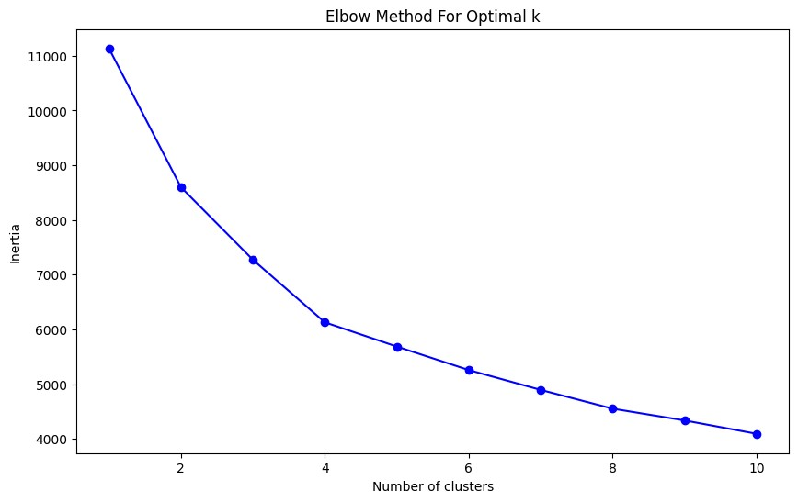

Figure 1: Finding optimal number of clusters using elbow method

From the figure, it was found out that the optimal number of clusters is 4 as it is the point at which graph shows a sudden change, like an elbow.